Module 3: Database Integration
Hands-On 5:
MongoDB — Document Modelling, CRUD & Aggregation

Task 1: Create the Collection and Insert Documents Goal: Set up the MongoDB collection and insert realistic feedback documents

60 & 61 : Create Database and Collection
Output:
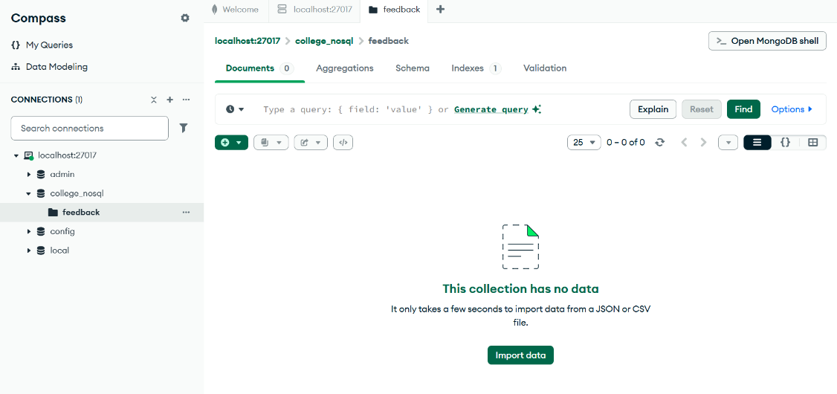

62. Insert Feedback Documents
Output:
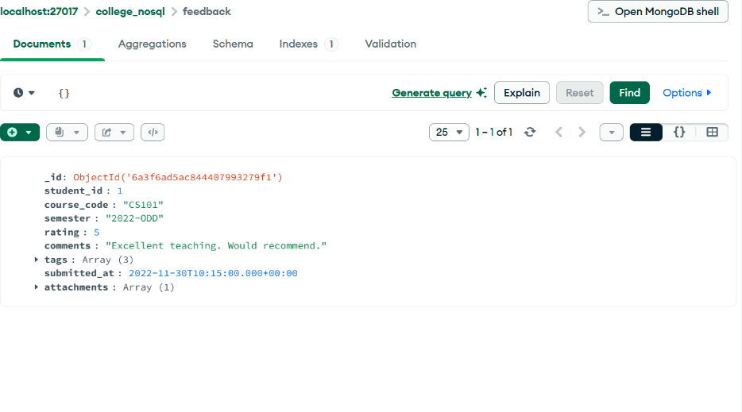
63: Insert Document Without Attachments Field
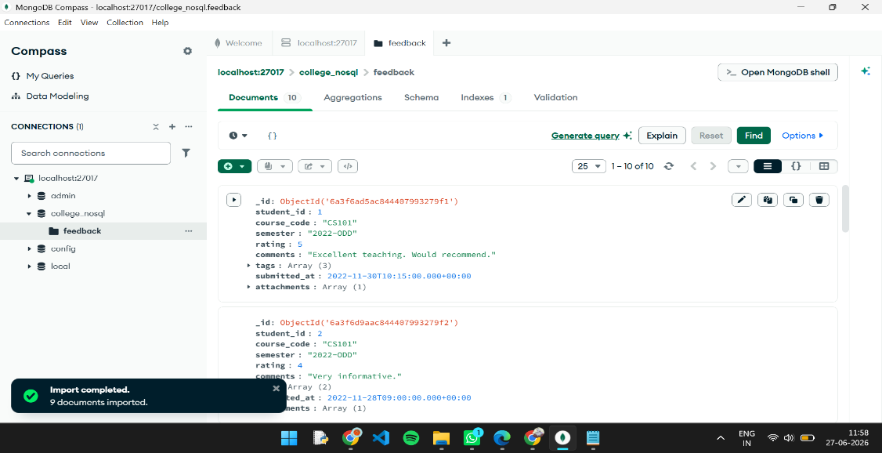

64: Verify Document Count

Task 2: CRUD Operations
65: Retrieve Feedback Documents Where Rating is 5
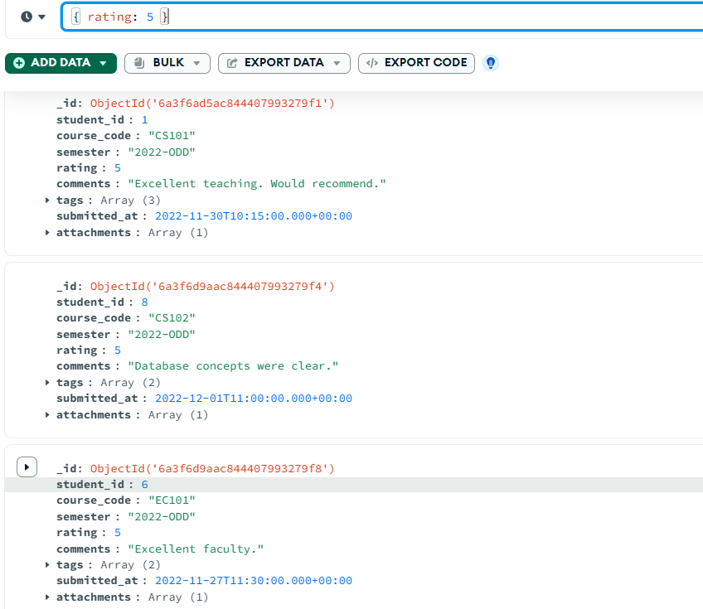

66: Retrieve CS101 Feedback Containing 'challenging' Tag
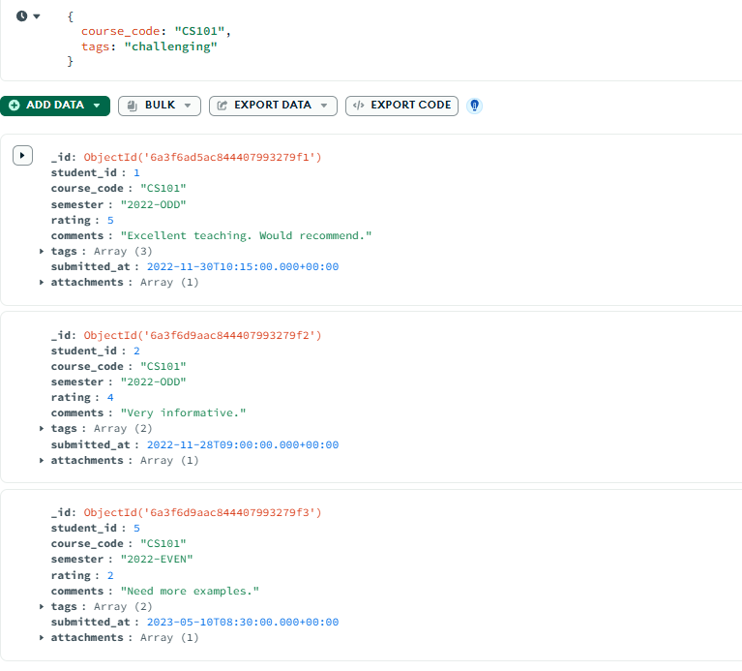
67: Retrieve Specific Fields Using Projection
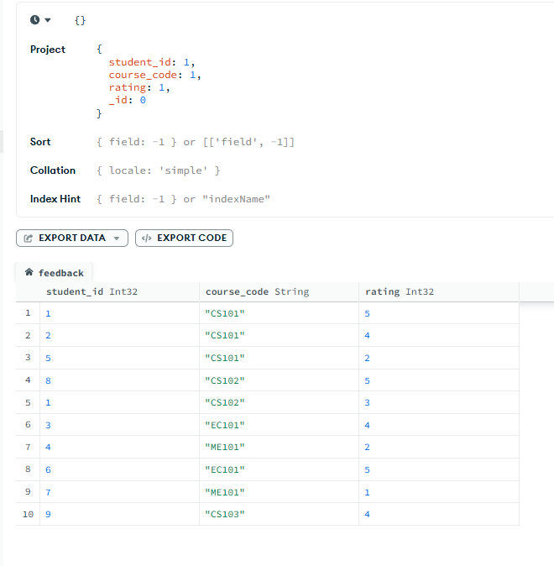
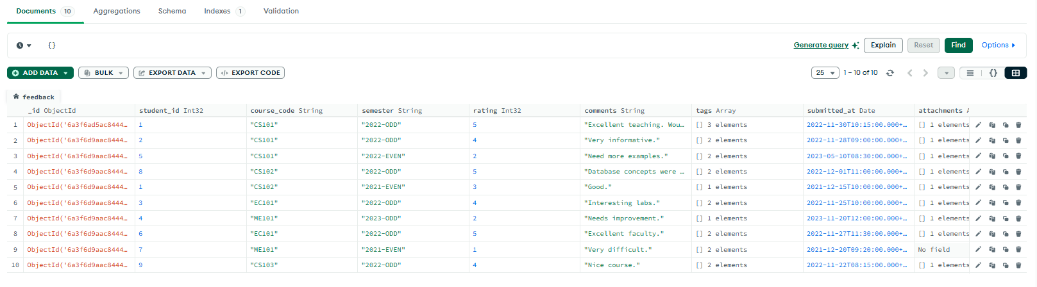

68: Add needs_review: true for Low Rated Feedback
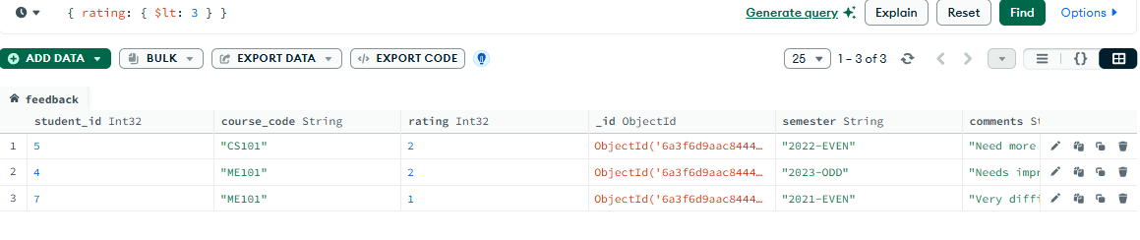
69: Push 'reviewed' into Tags Array
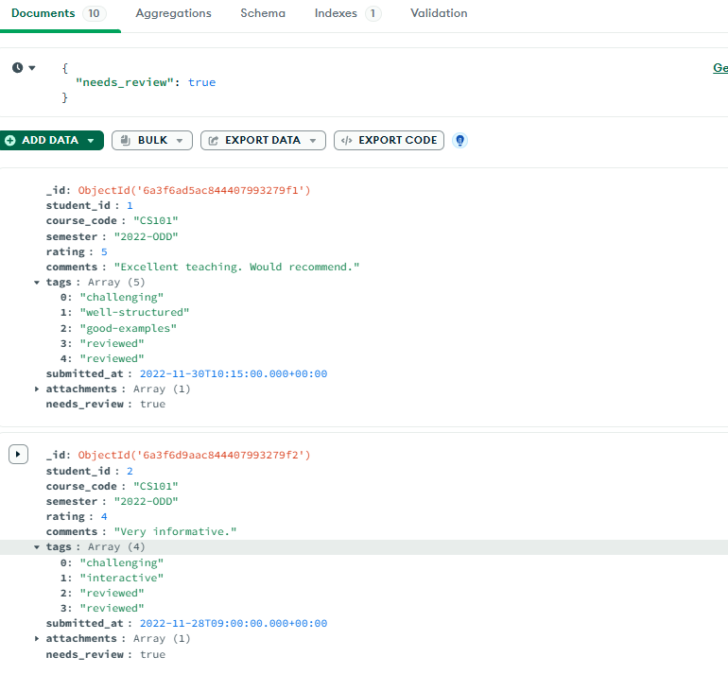

70: Delete Feedback Documents of Semester 2021-EVEN
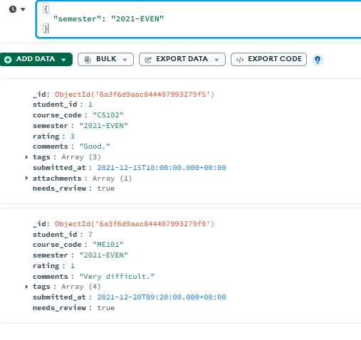
Task 3: Aggregation Pipeline
71. (Stage 1) filters to semester '2022-ODD.
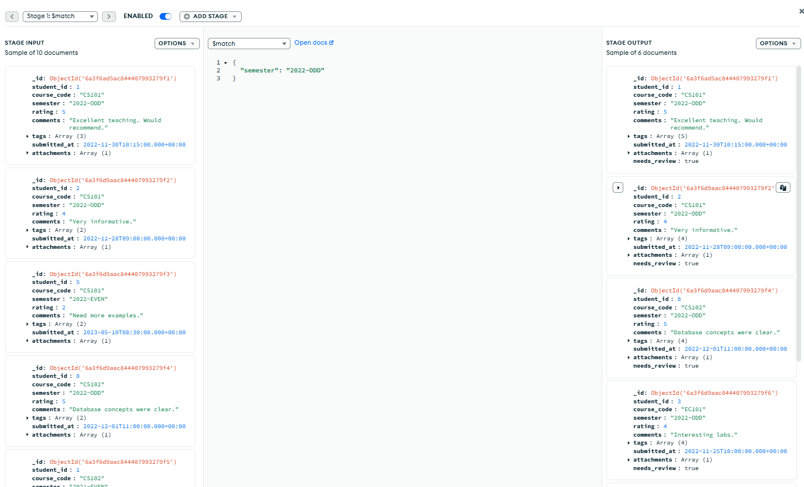
(Stage 2) groups by course_code calculating average rating and total feedback count.
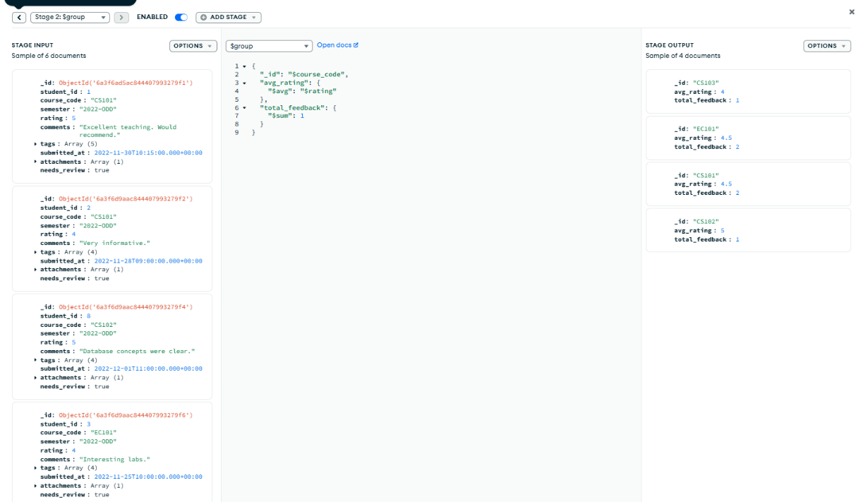
(Stage 3) sorts by average rating descending.
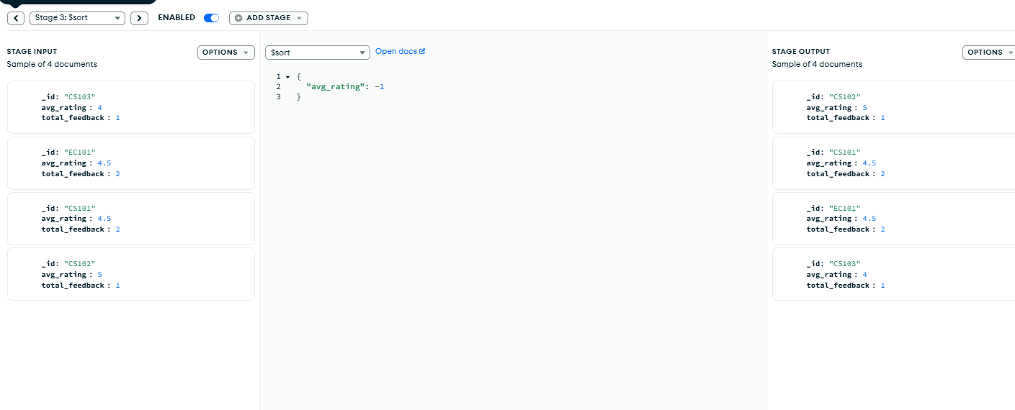
72. Renaming and Rounding Average Rating Using Projection
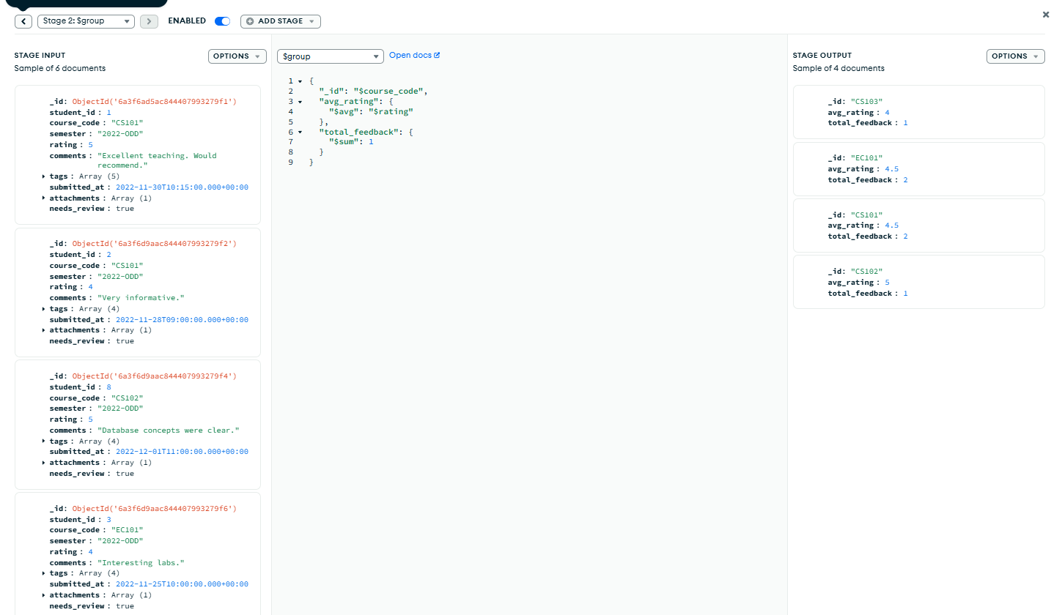

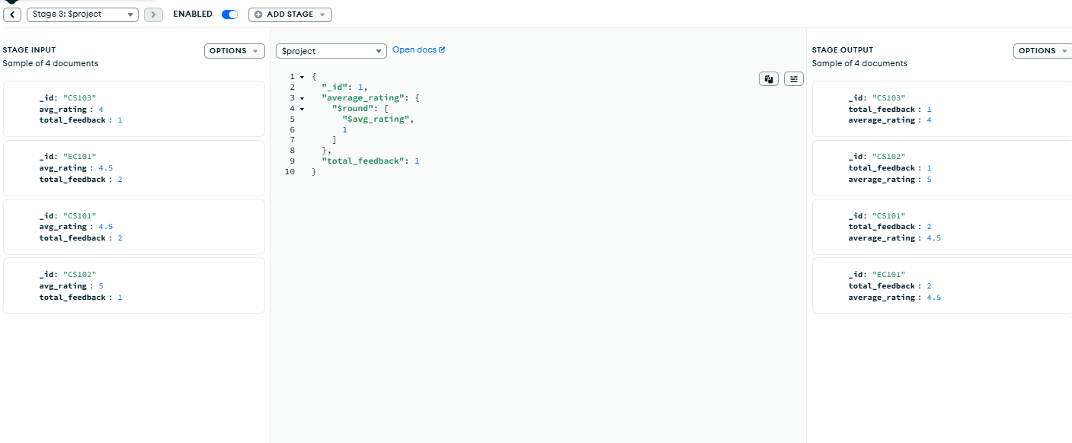

73. Tag Frequency Analysis Using Unwind and Group. Sort by count descending — a tag frequency leaderboard

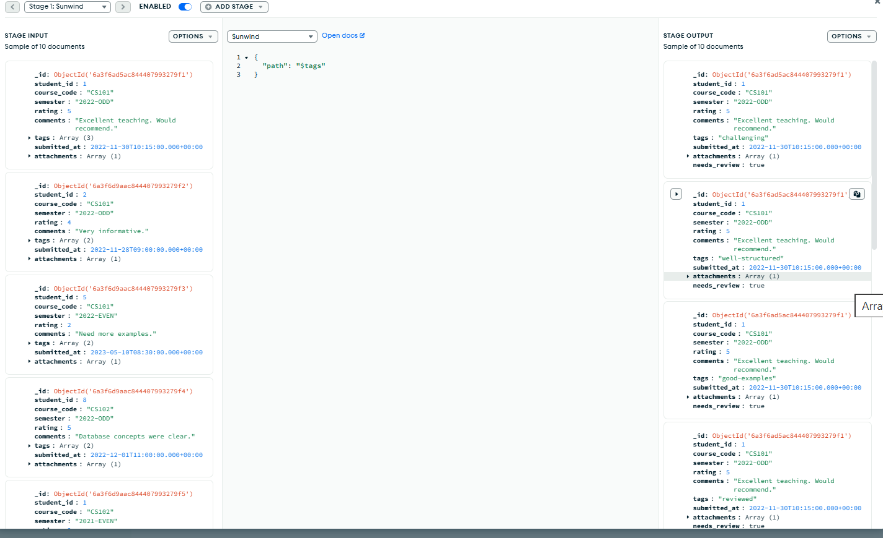

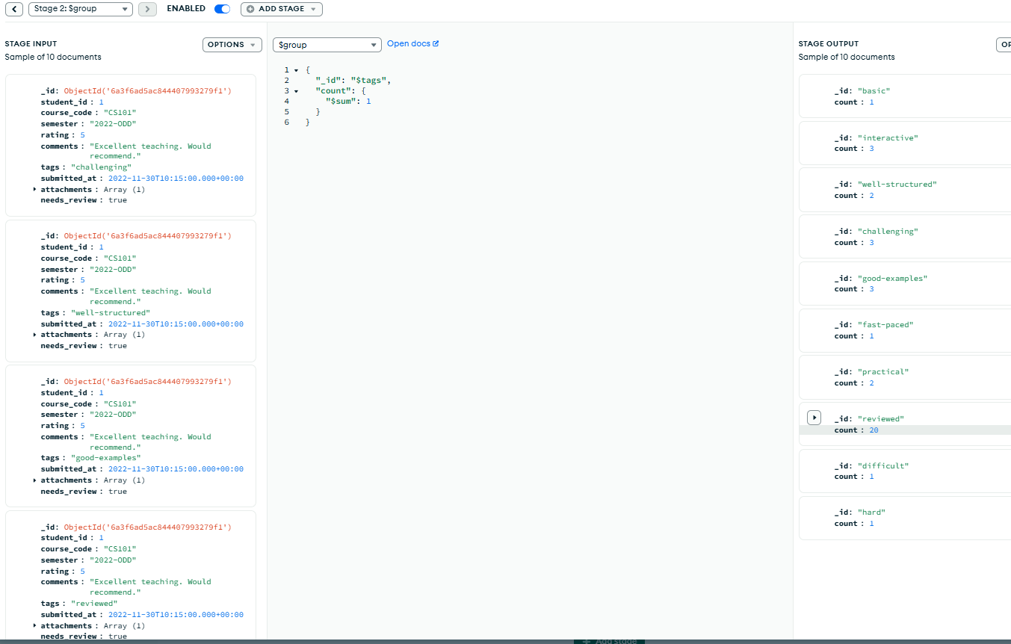
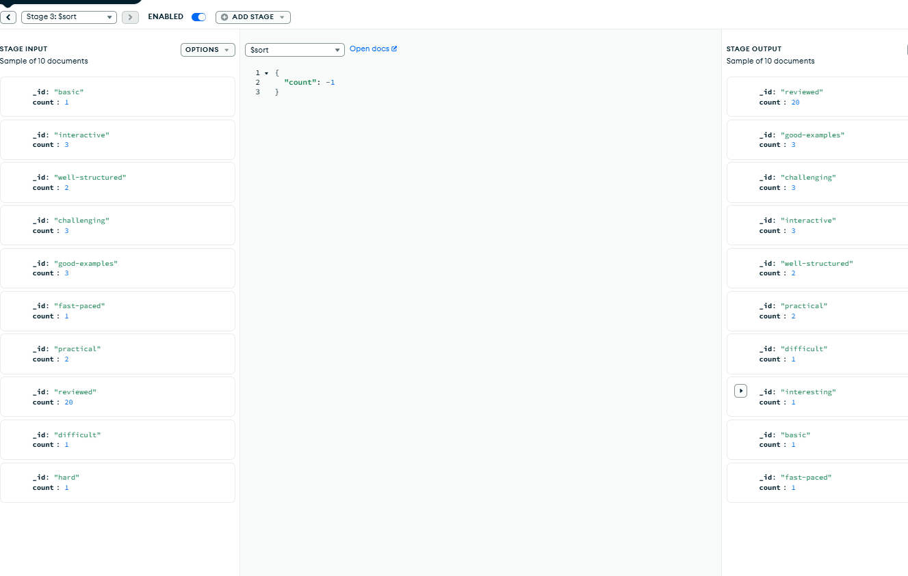
74. Index Creation and Verification Using Explain Plan

